Assignment 2 Data Surveying

For answering this assignment’s questions, python is used for all calculations and visualizing the data. This report will present the results and a brief explanation of codes. Statistical computation and plotting different types of charts are implemented by numpy, pandas, and matplotlib libraries.

As a preprocess, this dataset is read by pandas method (pd.read_csv), then attributes, tuples, and their types should be identified. Furthermore, missing numeric values are picked out and substituted for mean values and nominal missing data replaced with the mode as well.

* **Question 1**

The Auto Imports Database file includes 26 attributes and 205 instances which 15 attributes are continuous numeric data, 10 nominal data, and just 1 attribute is integer. Here is the Type of each of them:

|  |  |  |  |
| --- | --- | --- | --- |
| **No.** | **Attribute** | **Type** | **Range** |
| 1 | symbolling | Integer | From -3 to 3 |
| 2 | normalized-losses | Continuous | From 65 to 256 |
| 3 | make | Nominal | alfa-romero, audi, bmw, chevrolet, dodge, honda, isuzu, jaguar, mazda, mercedes-benz, mercury, mitsubishi, nissan, peugot, plymouth, porsche, renault, saab, subaru, toyota, volkswagen, volvo |
| 4 | fuel-type | Nominal | diesel, gas |
| 5 | aspiration | Nominal | std, turbo |
| 6 | num-of-doors | Nominal | four, two |
| 7 | body-style | Nominal | hardtop, wagon, sedan, hatchback, convertible |
| 8 | drive-wheels | Nominal | 4wd, fwd, rwd |
| 9 | engine-location | Nominal | front, rear |
| 10 | wheel-base | Continuous | 86.6 to 120.9 |
| 11 | length | Continuous | 141.1 to 208.1 |
| 12 | width | Continuous | 60.3 to 72.3 |
| 13 | height | Continuous | 47.8 to 59.8 |
| 14 | curb-weight | Continuous | 1488 to 4066 |
| 15 | engine-type | Nominal | dohc, dohcv, L, ohc, ohcf, ohcv, rotor |
| 16 | num-of-cylinders | Nominal | eight, five, four, six, three, twelve, two |
| 17 | engine-size | Continuous | 61 to 326 |
| 18 | fuel-system | Nominal | 1bbl, 2bbl,4bbl, idi, mfi, mpfi, spdi, spfi |
| 19 | bore | Continuous | 2.54 to 3.94 |
| 20 | stroke | Continuous | 2.07 to 4.17 |
| 21 | compression-ratio | Continuous | 7 to 23 |
| 22 | horsepower | Continuous | 48 to 288 |
| 23 | peak-rpm | Continuous | 4150 to 6600 |
| 24 | city-mpg | Continuous | 13 to 49 |
| 25 | highway-mpg | Continuous | 16 to 54 |
| 26 | price | Continuous | 5118 to 45400 |

* **Question 2**

All the computational process to get mean, standard deviation, mode, min, 25%, median, 75%, and max of numerical data are done by pandas df.describe() function and df.mode(). All their boxplots are also displayed by matplotlib function (axs.boxplot)

|  |  |  |  |  |  |  |  |  |  |
| --- | --- | --- | --- | --- | --- | --- | --- | --- | --- |
| **No** | **attribute** | **Mean** | **Standard deviation** | **mode** | **min** | **25%** | **median** | **75%** | **max** |
| 1 | symboling | 0.83 | 1.24 | 0 | -2 | 0 | 1 | 2 | 3 |
| 2 | normalized-losses | 122 | 31.68 | 122 | 65 | 101 | 122 | 137 | 256 |
| 3 | wheel-base | 98.76 | 6.02 | 94.5 | 86.6 | 94.5 | 97 | 102.4 | 120.9 |
| 4 | length | 174.05 | 12.34 | 157.3 | 141.1 | 166.3 | 173.2 | 183.1 | 208.1 |
| 5 | width | 65.91 | 2.14 | 63.8 | 60.3 | 64.1 | 65.5 | 66.9 | 72.3 |
| 6 | height | 53.72 | 2.44 | 50.8 | 47.8 | 52 | 54.1 | 55.5 | 59.8 |
| 7 | curb-weight | 2555.56 | 520.68 | 2385 | 1488 | 2145 | 2414 | 2935 | 4066 |
| 8 | engine-size | 126.91 | 41.64 | 92 | 61 | 97 | 120 | 141 | 326 |
| 9 | bore | 3.33 | 0.27 | 3.62 | 2.54 | 3.15 | 3.31 | 3.58 | 3.94 |
| 10 | stroke | 3.25 | 0.31 | 3.4 | 2.07 | 3.11 | 3.29 | 3.41 | 4.17 |
| 11 | compression-ratio | 10.14 | 3.97 | 9.0 | 7.0 | 8.6 | 9.0 | 9.4 | 23.0 |
| 12 | horsepower | 104.26 | 39.52 | 68.0 | 48.0 | 70.0 | 95.0 | 116.0 | 288.0 |
| 13 | peak-rpm | 5125.37 | 476.98 | 5500.0 | 4150.0 | 4800.0 | 5200.0 | 5500.0 | 6600.0 |
| 14 | city-mpg | 25.22 | 6.54 | 31 | 13.0 | 19.0 | 24.0 | 30.0 | 49.0 |
| 15 | highway-mpg | 30.75 | 6.89 | 25 | 16.0 | 25.0 | 30.0 | 34.0 | 54.0 |
| 16 | price | 13207.13 | 7868.77 | 13207.13 | 5118.0 | 7788.0 | 10595.0 | 16500.0 | 45400.0 |

**Boxplot of numeric data:**

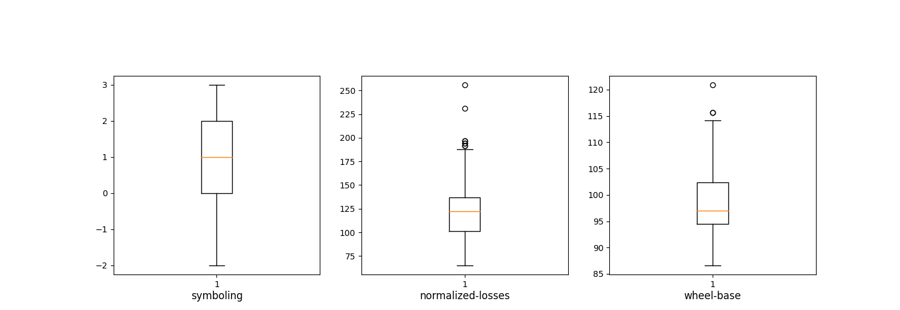

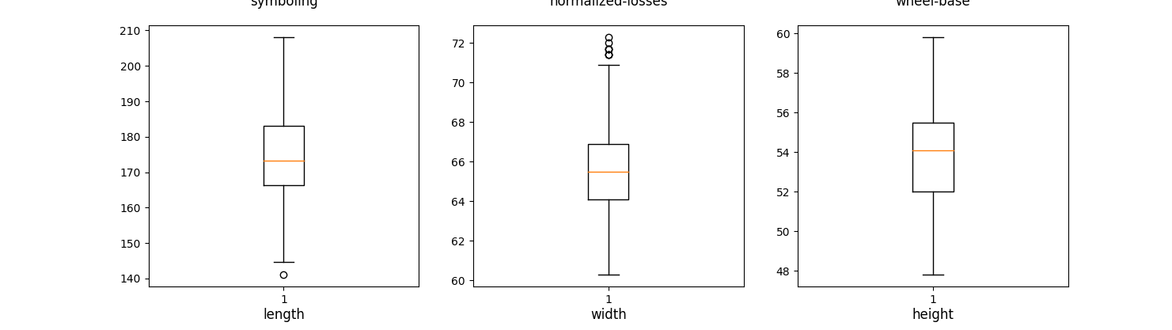

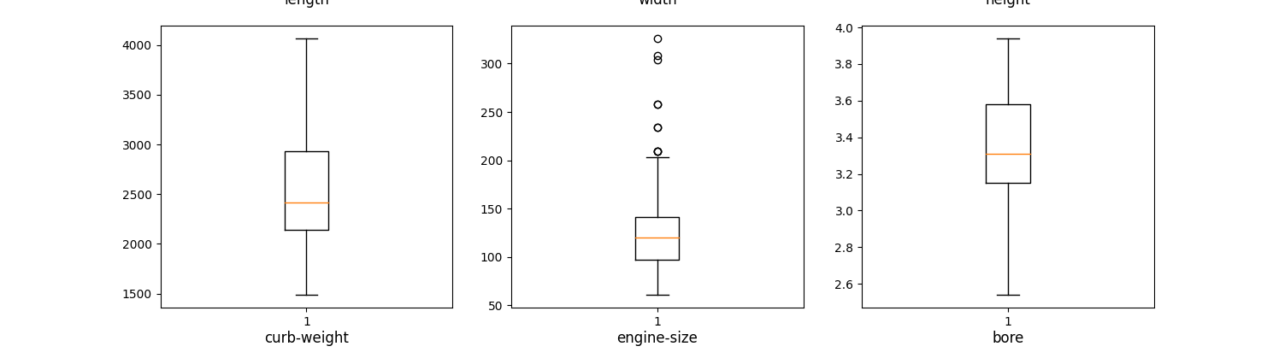

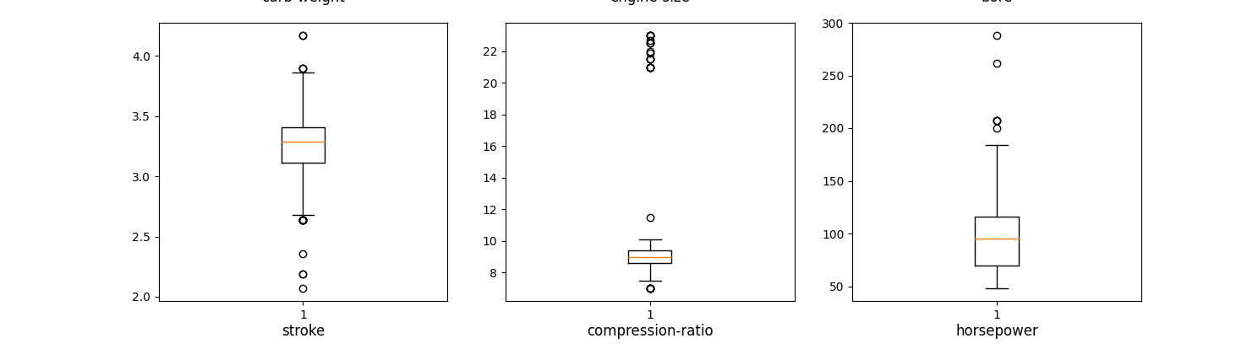

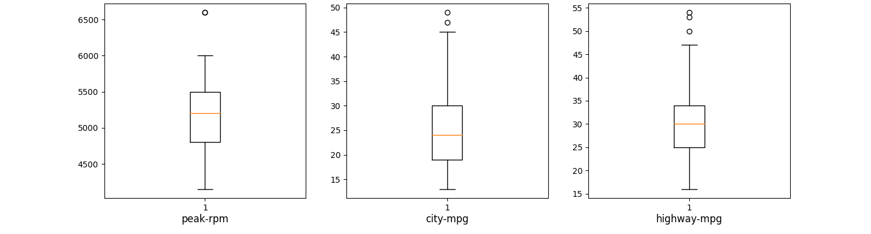

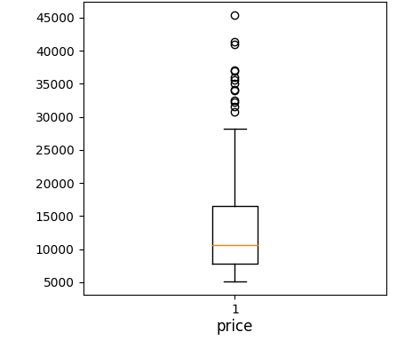

* **Question 3**

These boxplots show the distributions of price between the different body styles category.

In pandas library, boxplots of variables distributions grouped by the values of a third variable can be created using the argument *by.*

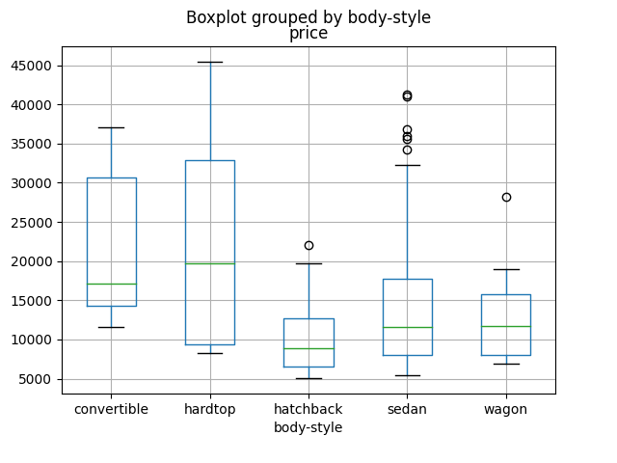

* **Question 4**

This histogram shows the distribution of horsepower. The values are between 48 and 288 and divided into three equal lengths.

For displaying this histogram, one attribute (hp_category) is added to the data with nominal objects (Low, Medium, and High) in order to define the counts of each new distinct values of this attribute and display its histogram by using df.plot.bar() function.

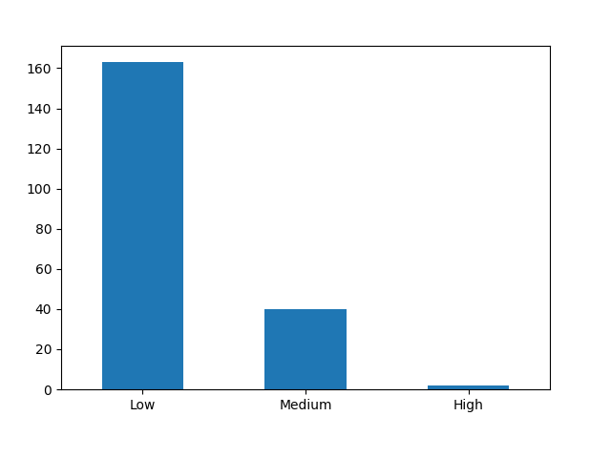

* **Question 5**

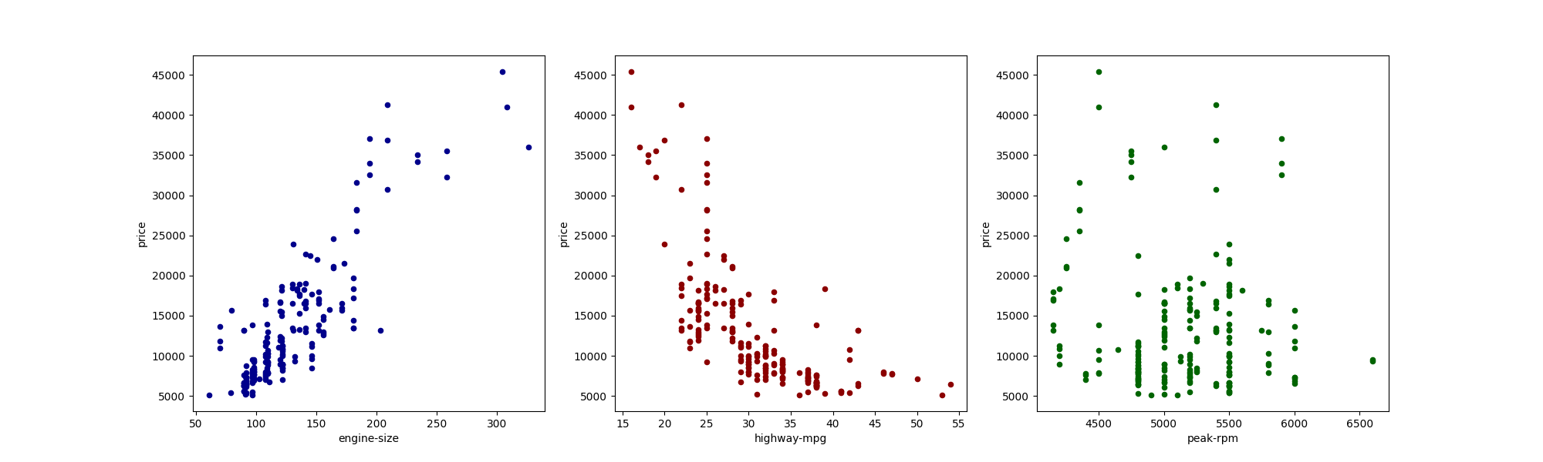

The first scatterplot shows the relatively positive correlation between engine size and price. Thus the larger engine size of the car, we could expect a higher price. The scatterplot between highway-mpg and price shows the different correlation. It approximately has a negative correlation which means the price of the car gets lower when the value of highway-mpg is bigger. The data in the third plot has no relationship which is seen in the two other plots. It seems that there is no relation between peak-rpm and the car price.

Using the df.plot.scatter function is sufficient for these data in order to show mentioned scatter plots in python.

* **Question 6**

To visualizing three different attributes (body style, drive wheel, and price) that two of them are categorical (nominal) and the other one is numeric and continuous data, the chart below could describe the relationships among them.

On the axes of the chart, there are two categorical attributes. So there are 15 combinations, for instance: cars with hard top body-style and RWD drive-wheel. But as the chart shows, neither hardtop body-style with 4wd wheel-style nor convertible with 4wd wheel-style doesn’t exist in the data. For each of these combinations, the mean price is calculated and shown as a purple dot. The larger dot for one case points out the higher price for it. Hence, this chart indicates that any types of body-style with RWD wheel-style are more expensive than other wheel-styles. On the other hand, all types of body-style with FWD wheel-style are the cheapest. Although 4WD style doesn’t manufacture for hardtop and convertible body styles, the prices of this kind of wheel for other body-style are a little bit more expensive than cars with FWD style.

In python, the dictionary data structure is used to store all combinations of car’s body-style and wheel style mapped to each groups’ count and sum price. Then the mean price is calculated for each key. Then we create a new pandas data frame with three attributes (drive-wheel, body-style, and mean price). The last step in the code is using pandas scatter plot so as to visualize this new data frame and analyze it.

